JavaScript Task (10 Oct 2025)
Name: Manas Pinjarkar
Prn: 23070521089
Sem/Sec: 5th (B)

Task1
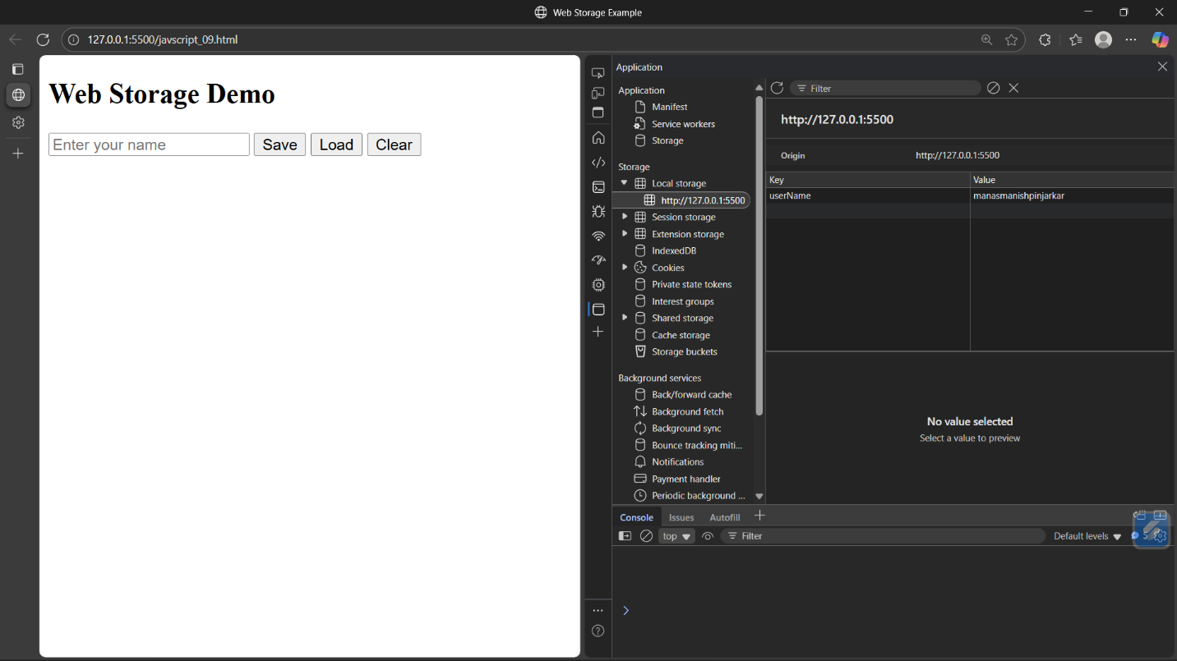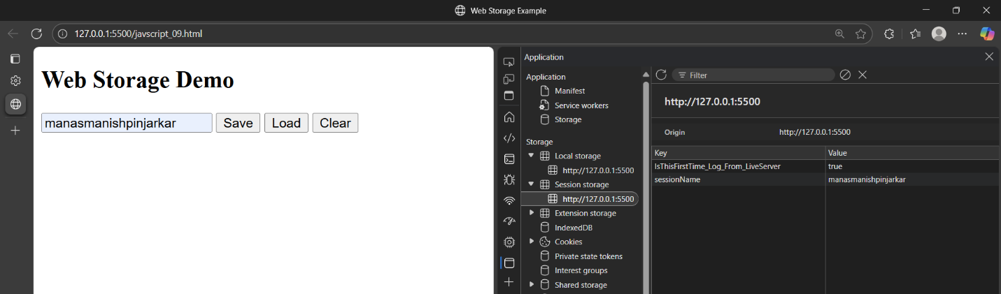
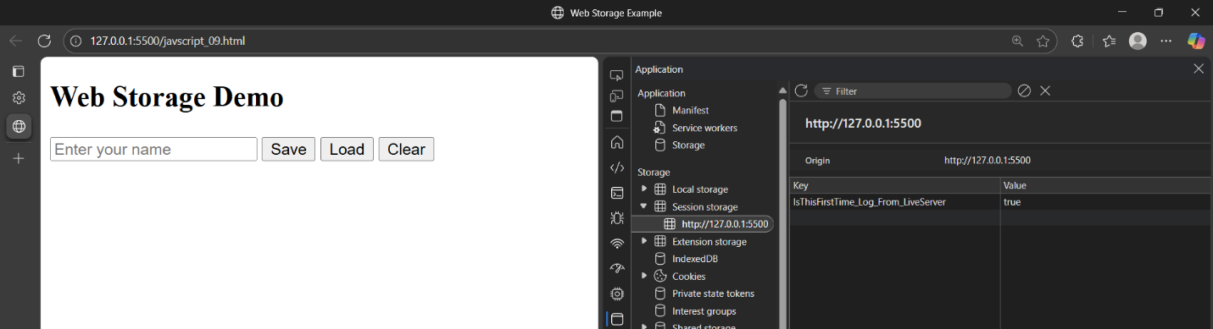

Task2:
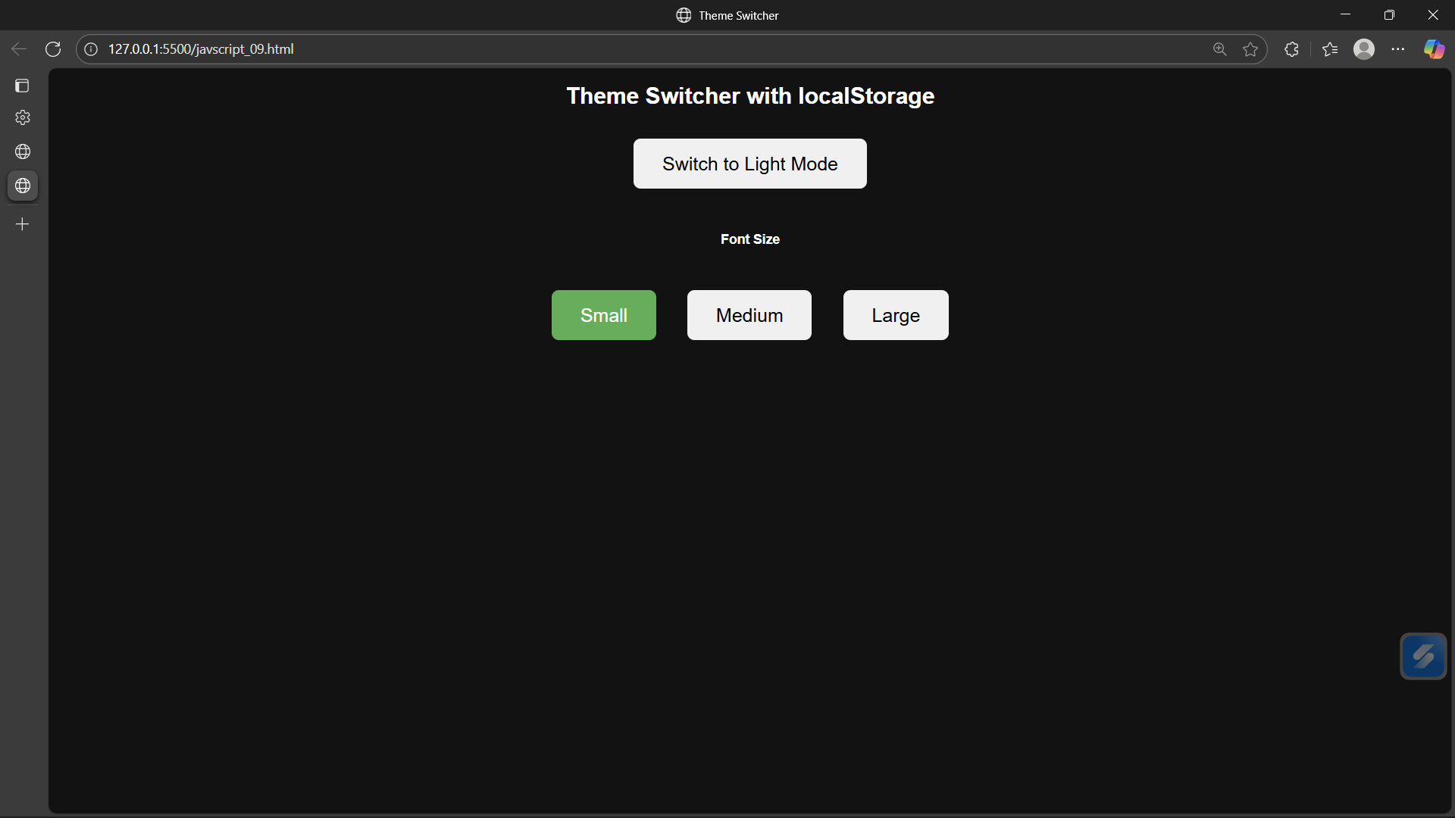
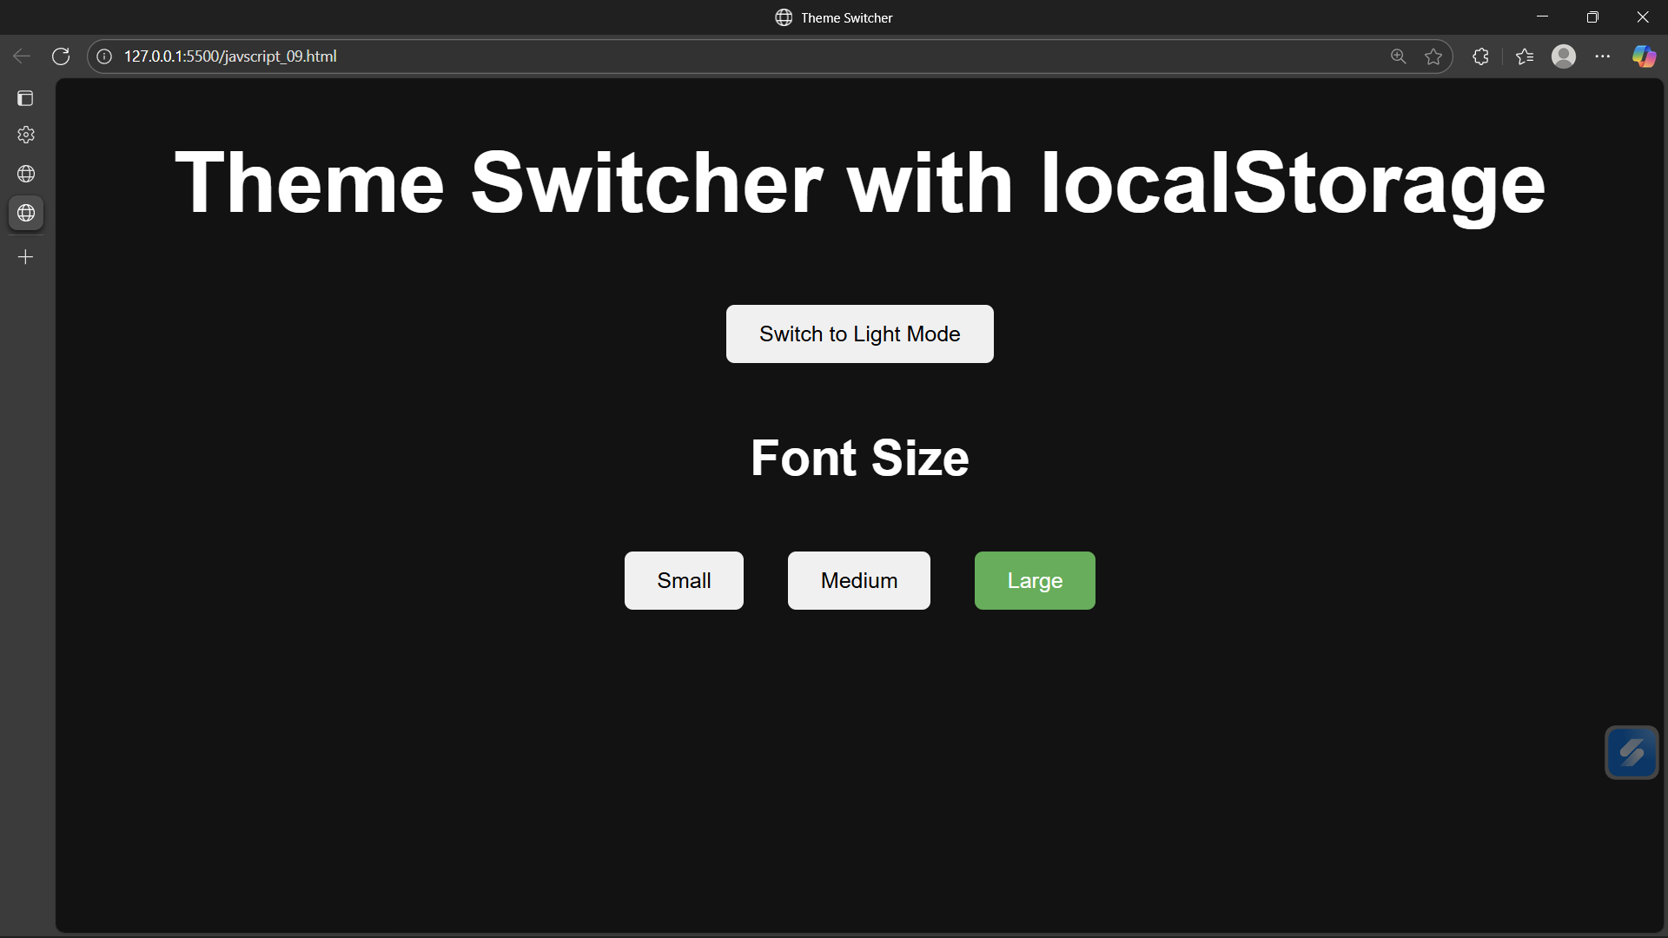
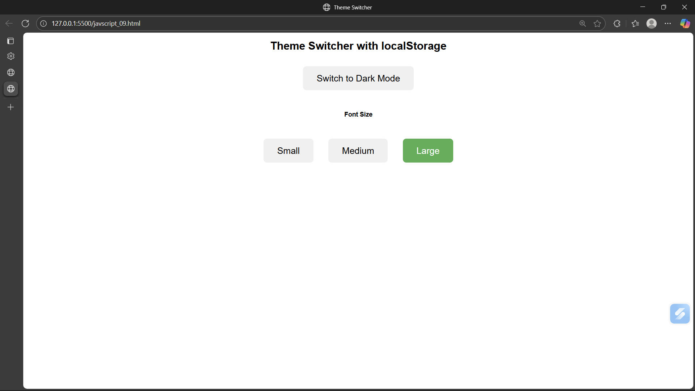

Task3

